INSTALLATION, SERVICING, AND PRODUCTION TESTING OF
ANDERSON BRASS
200RV WATER SERVICE PANELS

BACKGROUND –

The Anderson Brass 200RV Water service panel provides inlet backflow prevention (inlet service check) at the hose bib service entrance, along with a diverter valve that offers the four following functions:

1). Dry Camping (“Normal”) – Pumping from the on-board tank with the on-board pump at a maximum water pressure of 45 psi and 2.5 gpm.
2). City Fixtures – Diverting water pressure not to exceed 80 psi from a hose connected to the inlet backflow preventer to the fixtures on the RV.
3). Tank Fill – Diverting water pressure not to exceed 80 psi from a hose to the on-board holding tank equipped with adequate means for air venting and over-fill protection.
4). Sanitizing and Winterizing – Drawing water, sanitizer, or RV grade winterizer from a bucket through a hose connected to the inlet backflow preventer using the on-board pump and diverting this flow to the fixtures.

The 4 function fill valve utilizes a one piece rotor with rubber seats that are serviceable without removal of the valve. It is constructed with ABCO’s standard click mechanism to assure specific port orientation and selection. All connection ports are ½” Male NPT fittings for easy installation of Pex adapters, Flare-It adapters, or flexible connectors with or without conical seal washers.
The backflow preventer (service check) valve is constructed of lead free brass and has a full brass swivel nut for field longevity.

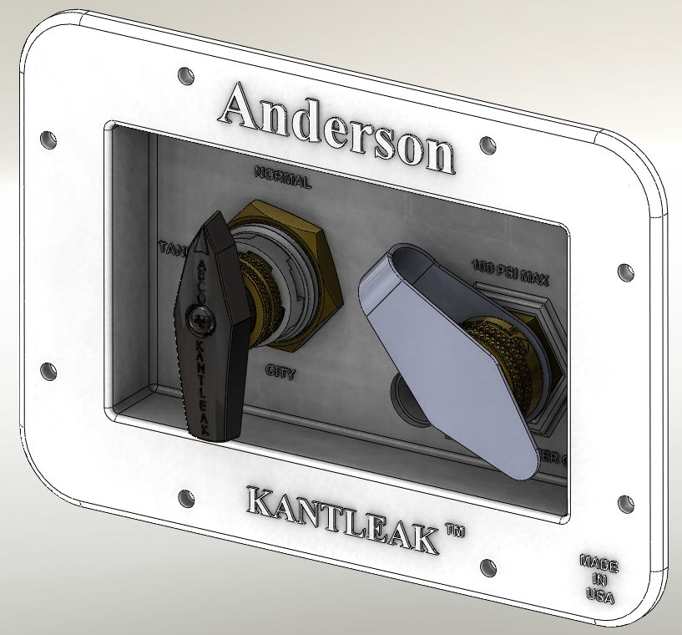

Diverter Backflow
Valve Preventer
(Service Hose
Connection)
3/8” or ½”
Vent

OPERATING CONDITIONS:
Working temperature: 32 to 120ºF
Maximum pressure: 100 psig Water

INSTALLATION –

The panel needs to be mounted through a 3 1/4” x 5 ½” opening in a service panel or side wall. All four ports of the diverter valve are labeled for connection as detailed below. The inlet of the diverter valve should be connected to the outlet of the inlet backflow preventer for all installations not requiring a water filter. The remaining lines are labeled PS for “Pump Suction”, TK for “Tank”, and PD for “Pump Discharge” or fixtures. All fittings are ½” pipe thread with a provision for ID conical seals from typical PEX fitting adapters.

In installations using a water filter, the filter needs to be installed in the line between the service check valve and the inlet to the 4-function valve. All other installation the discharge of the service check needs to be connected to the 4 function valve inlet most conveniently with a ½” by ½” flexible connector.
Pump Switch Knockout
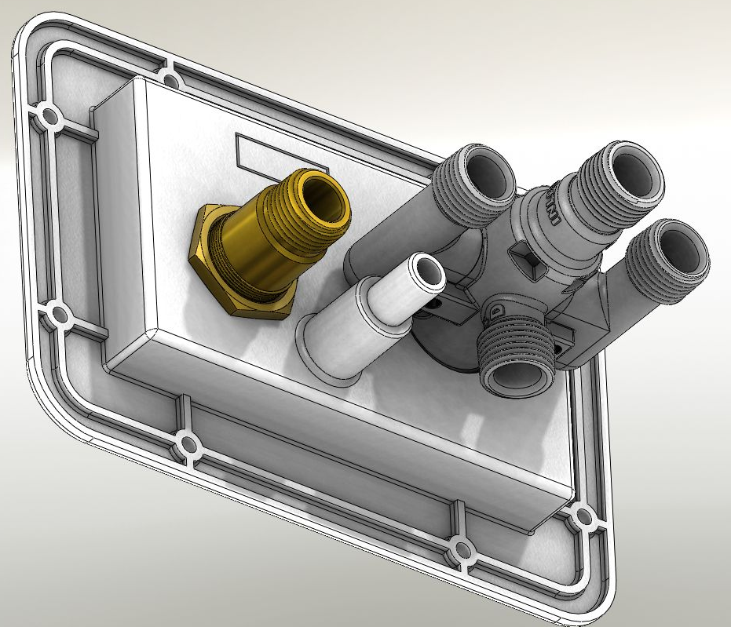
Service Check Diverter
½”NPT Outlet ½”NPT
(to Diverter Inlet Inlet
Or Water Filter)
Pump
Suction
½”NPT

3/8” or ½” Vent Tank
Connection Fill
½” NPT

Fixture
Supply
½” NPT
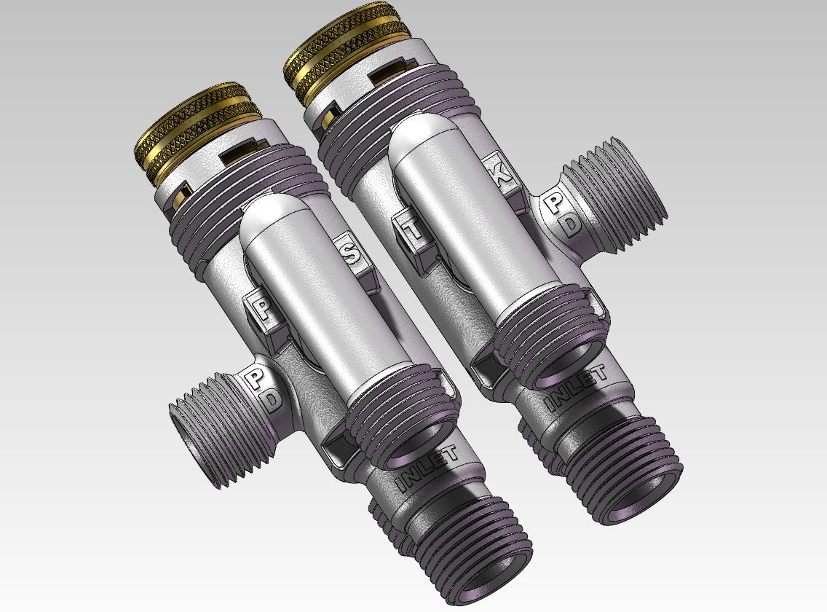
Pump Suction Tank

Pump Discharge
(Fixtures)

Inlet
(From Check)

INSTALLATION (CONTINUED)
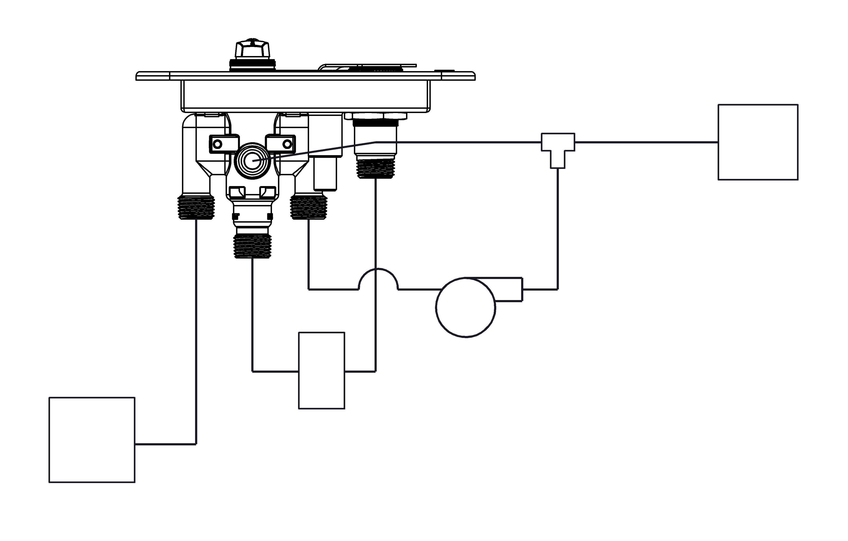

Fixtures

Pump
Opt
Filter

Holding
Tank

SERVICING
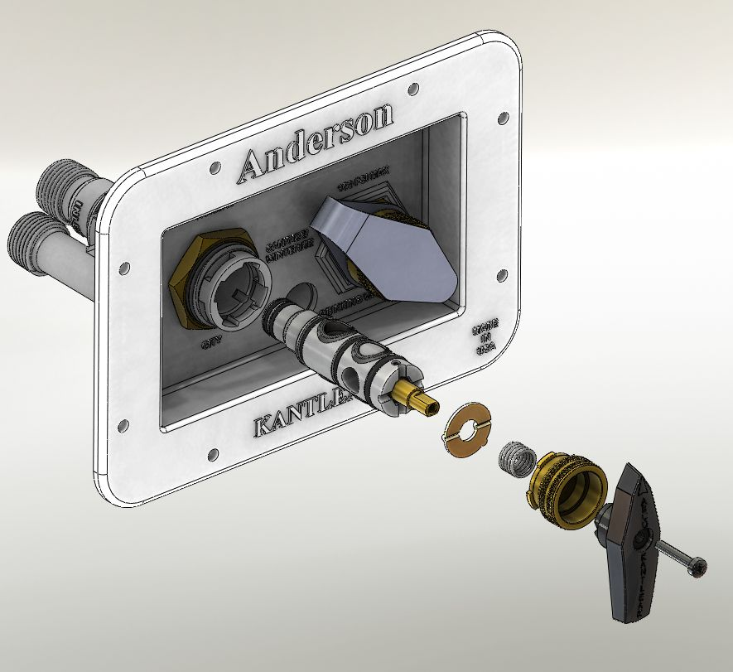
The central rotor of the 4-Function valve can be removed through the bonnet bayonet nut without removing the valve from the lines. Insure that the system is depressurized by opening drain lines, turning off the pump, and removing city water connections. Remove the handle and depress the bonnet nut towards the panel and rotate the bonnet 5-10 degrees counterclockwise to release the bonnet nut. Remove the spring and washer followed by the rotor. The seats in the rotor are replaceable under Anderson Brass part number 9X35. The rotor needs to be reinstalled using a food grade grease like Dow Corning 111 with liberal amounts at each seal interface.

Seats O-Rings

TESTING –

NFPA 1192 as mandated by RVIA requires an air and water test at 80 psi for 10 minutes
without leakage or loss of pressure.

Step 1 – Air Test – With the water heater removed and lines capped and the diverter valve set in the “City” position (and not moved throughout the test) air pressure at 80 psi must be applied with a suitable test fitting that holds the inlet check valve open to the inlet service (backflow preventer) connection only! A gage and isolation valve on the adapter fitting will allow a continuous reading of service pressure after the inlet isolation valve is closed. After ten minutes there should not be any fall off in air pressure.

Step 2 – Water test – With the water heater installed and the diverter valve set to the “city” position (and not moved throughout the test), fill the entire system with water until is can be seen from the tank vent line. Bring the pressure up to 80 psi and hold for 10 minutes. Do not close the inlet valve as pressure fall off will occur due to the incompressible nature of water. Visually inspect the entire plumbing system for leaks.

Step 3 – Diverter Valve Seat Test (Completely optional – not NFPA 1192 Mandated) – With the system still filled with water move the selector valve to the “Normal” (dry camping) position and remove the tank fill line at the diverter valve and inspect for visual leakage. This will insure that an internal leak at the diverter will not over-fill a holding tank. Do not use air for this test as the seat design in the valve is for zero leakage on water. Do not use soap solution and water bubble testing and simply inspect for visual leakage.

